|  |
| --- |
| LIST OF ABBREVIATIONS ................................................................................. |
| LIST OF FIGURES ……….................................................................................... |
| ABSTRACT ............................................................................................................ |
| INTRODUCTION………................................................................. |
| PROBLEM DEFINITION ………..................................................... |
| PROJECT DESCRIPTION.................................................................... |
| REQUIREMENTS ................................................................................ |
| METHODOLOGY................................................................................ |
| EXPERIMENTATION.......................................................................... |
| RESULTS AND ANALYSIS ….............................................................. |
| CONCLUSION AND FUTURE WORK ….............................................................. |
| REFERENCES... ....................................................................................................... |
| CODE/PROGRAM ......................................................................... |

**TABLE OF CONTENTS**

**LIST OF FIGURES:**

|  |
| --- |
| Fig.1: |
| Fig.2: |
| Fig.3: |
| Fig.4: |
| Fig.5: |
| Fig.6: |

**ABRIVATION:**

nltk: Natural Language Toolkit

Chat, reflections: Classes or modules from the NLTK library for creating a chatbot.

API: Application Programming Interface

SDK: Software Development Kit

AI: Artificial Intelligence

NLP: Natural Language Processing

abstract:

Interest in chatbot development is on the rise. As a usability evaluation is an essential step in chatbot development, the number of experimental studies on chatbot usability has grown as well. As a result, we think a systematic mapping study is opportune. We analyzed more than 700 sources and retrieved 28 primary studies. By aggregating the research questions and examining the characteristics and metrics used to evaluate the usability of chatbots in experiments, it is possible to identify the state of the art in chatbot usability experimentation. We conducted a systematic mapping study to identify the research questions, characteristics, and metrics used to evaluate the usability of chatbots in experiments. Most experiments adopted a within-subjects design. On the other hand, few experiments provided raw data, and only one of the identified papers was part of a family of experiments. Effectiveness, efficiency, and satisfaction are usability characteristics used to identify how well users can learn and use chatbots to achieve their goals and how satisfied users are during the interaction. Generally, the experimental results revealed that chatbots have several advantages (e.g., they provide a real-time response and they improve ease of use) and some shortcomings (e.g., natural language processing, which is rated as the weakness most in need of improvement). This research offers an overview of chatbot usability experimentation. The increasing interest in this area is very recent, as works did not start to be published until 2018. Chatbot usability experiments should be more replicable to improve the reliability and transparency of the experimental result

**INTRODUCTION**

The provided Python code introduces a basic yet functional customer support chatbot utilizing the Natural Language Toolkit (NLTK) library. In the realm of artificial intelligence and conversational agents, chatbots have become integral for enhancing user experiences and providing instant assistance. This particular implementation showcases how NLTK, a powerful library for natural language processing, can be employed to create a customer support chatbot capable of engaging in interactive conversations with users.

The code begins by importing the necessary NLTK modules, including the Chat class and reflections. It initializes the NLTK 'punkt' resource, crucial for tokenization in natural language processing tasks. The heart of the chatbot lies in the definition of conversation pairs—a structured mapping between user input patterns and corresponding bot responses. These pairs cover a diverse range of topics commonly encountered in customer support scenarios, such as order inquiries, product issues, and technical support.

The user interacts with the chatbot by entering queries, and the code processes these inputs to generate appropriate responses based on the predefined pairs. Notably, the chatbot maintains a polite and informative tone, contributing to a positive user experience. The code structure allows for easy customization and extension, enabling businesses or developers to adapt the chatbot to specific needs or integrate more advanced features.

While the code provides a foundational understanding of creating a chatbot using NLTK, it is a starting point that can be expanded upon for more sophisticated applications. Overall, the code serves as an educational tool for those interested in exploring natural language processing and chatbot development within the Python programming language.

**PROBLEM DEFINITION**

Using a chatbot can be an effective way to overcome customer service problems and enhance the overall customer experience. Here are several strategies to implement a successful chatbot for customer service:

**1. Understand Customer Needs:**

- Analyze customer queries and common issues to identify the areas where a chatbot can be most beneficial.

- Conduct surveys or gather feedback to understand customer preferences and pain points.

**2. Clear Purpose and Scope:**

- Clearly define the purpose and scope of your chatbot. Ensure that it is designed to handle specific types of queries or tasks rather than trying to cover everything.

**3. User-Friendly Design:**

- Develop a user-friendly interface that is easy to navigate. The chatbot should guide users through the conversation logically.

**4. Natural Language Processing (NLP):**

- Implement Natural Language Processing capabilities to enable the chatbot to understand and respond to user queries in a conversational manner. This enhances the user experience by making interactions more human-like.

**5. Multi-Channel Integration:**

- Integrate the chatbot with various communication channels, including website chat, social media, and messaging apps, to provide a seamless experience across platforms.

**6. Escalation to Human Agents:**

- Design the chatbot to recognize when it cannot adequately address a user's query and seamlessly escalate the conversation to a human customer service agent.

**7. Continuous Learning and Improvement:**

- Implement machine learning algorithms to enable the chatbot to learn from interactions and improve over time. Regularly update and refine the chatbot based on user feedback and evolving customer needs.

**8. Personalization:**

- Use customer data to personalize interactions. A chatbot that can reference previous interactions and understand customer preferences can provide a more tailored experience.

**9. Transparency:**

- Clearly communicate to users that they are interacting with a chatbot. Transparency builds trust and helps manage customer expectations.

**10. 24/7 Availability:**

- One of the advantages of chatbots is their ability to provide round-the-clock assistance. Ensure that your chatbot is available 24/7 to address customer inquiries in different time zones.

**11. Testing and Optimization:**

- Regularly test the chatbot in different scenarios to identify and address any issues. Continuously optimize its performance based on real-world usage.

**12. Educate Customers:**

- Provide information to customers about the capabilities of the chatbot and how it can assist them. Encourage users to use the chatbot for common queries and routine tasks.

By carefully implementing these strategies, businesses can create a chatbot that not only resolves customer service problems but also enhances the overall customer experience.

**PROJECT DISCRPTION:**

The Python code presented extends an existing customer support chatbot implemented using the NLTK library. NLTK is widely used for natural language processing, and in this context, it serves as the foundation for creating a responsive and versatile chatbot. The purpose of the code is to train the chatbot to handle an expanded set of user queries and issues, enhancing its ability to provide informative and helpful responses.

The core of the code is the definition of a list named 'pairs,' where each element represents a pair comprising a user input pattern and a corresponding set of potential responses. These pairs are pivotal in shaping the chatbot's understanding of user intent and form the basis for crafting appropriate replies. Initially, the pairs cover general greetings, specific issues, and basic customer service scenarios.

To augment the chatbot's capabilities, the code introduces additional pairs, broadening its coverage to address an extensive array of user interactions. New pairs are incorporated to handle inquiries related to product returns, damaged items, shipping options, refund status, and adjustments to orders. The chatbot is trained to address specific concerns such as gift card inquiries, newsletter subscriptions, and user complaints.

The chatbot's responses are crafted to guide users through various processes, encouraging them to provide necessary details for more effective assistance. The code maintains a user-friendly and informative tone, expressing empathy when users report issues or complaints. It covers diverse topics, including technical issues on the website, sustainability initiatives, and participation in loyalty programs.

In essence, the added pairs contribute to a comprehensive customer support experience, making the chatbot more adept at addressing the nuanced needs and queries of users. The chatbot strives to offer clear and concise instructions, ensuring that users receive relevant information and guidance in a polite manner. The overall goal is to create an interactive and helpful conversational agent that can successfully navigate a diverse range of customer interactions, from simple queries to more complex issues.

**REQUIREMENTS**

1**.NLTK Library:** The code utilizes the Natural Language Toolkit (NLTK) library, a popular library for natural language processing in Python. Ensure that NLTK is installed before running the code. You can install it using:



Fig.1

**2.Language Resources** for NLTK: The NLTK library relies on language resources such as tokenizers and corpora. In the code, it downloads the 'punkt' resource. Make sure to download this resource using:



Fig.2

**3.Python Interpreter:** Ensure that you have a Python interpreter installed on your system. The code is compatible with Python 3.

**4.Input Mechanism:** The code takes user input through the input function in the console. If you are running this in an environment that doesn't support console input (like certain IDEs or online platforms), you might need to adapt the input mechanism.

**5.Internet Connection:** The NLTK download requires an internet connection to fetch the 'punkt' resource. Make sure your system has internet access during the initial run.

Once these requirements are met, you should be able to run the code successfully. Keep in mind that the NLTK library and its resources might require occasional updates, so it's a good practice to check for updates or follow any prompts related to NLTK during execution.

**METHODOLOGY**

The methodology for the provided code involves creating a simple yet effective customer support chatbot using the NLTK library in Python. Below is a step-by-step breakdown of the methodology:

**1**. **Import Libraries:**

- Import the necessary libraries, including nltk, Chat, and reflections from nltk.chat.util.

**2.** **Download NLTK Resources:**

- Download the required NLTK resources, in this case, the 'punkt' tokenizer.



Fig.3

**3. Define Conversation Pairs:**

- Define conversation pairs to train the chatbot. Each pair consists of a user input pattern (regular expression) and a list of possible responses.

**4. Create Chatbot Function:**

- Define a function, e.g., customer_support_chatbot(), to handle the chatbot's interaction.

- Utilize the Chat class from NLTK to process user input and generate responses based on the predefined pairs.

**5. Interactive User Input:**

- Use a loop to continuously take user input and provide responses until the user decides to exit (e.g., by typing "goodbye").

**6. Enhance Chatbot Functionality:**

- Extend the conversation pairs to cover a wide range of user queries and issues.

- Include responses for common customer support topics such as order status, payment issues, returns, and more.

**7. Maintain Polite and Informative Responses:**

- Ensure that the chatbot maintains a polite and helpful tone in its responses to enhance the user experience.

**8. Encourage User Engagement:**

- Encourage users to provide additional details when necessary for a more personalized response.

- Provide instructions for common actions, such as updating information or subscribing to newsletters.

**9. Execute the Chatbot:**

- Call the customer_support_chatbot() function to initiate the chatbot and engage in a conversation with users.

**10. Adapt and Customize:**

- Customize the conversation pairs based on specific requirements and expand the code to cover additional scenarios as needed.

**11. Documentation:**

- Include comments and documentation to explain the purpose and functionality of different parts of the code.

**12. Testing and Iteration:**

- Test the chatbot with various user inputs to ensure it responds appropriately to different scenarios.

- Iterate on the code to refine responses, add more conversation pairs, and improve the chatbot's overall effectiveness.

By following this methodology, the code aims to create an interactive and responsive customer support chatbot capable of handling a variety of user inquiries.

**EXPERIMENTATION**

Welcome to Customer Support Chatbot. Type 'goodbye' to exit.

You: hi

Bot: Hello!

You: How do I check the status of a repair or service request?

Bot: To check the status of a repair or service request, please provide the reference number, and we'll provide you with an update.

You: I received a damaged product

Bot: I apologize for the inconvenience. Please provide your order number, and we will arrange for a replacement or refund.

You: goodbye

Goodbye! Have a great day.

Welcome to Customer Support Chatbot. Type 'goodbye' to exit.

You: hi

Bot: Hello!

You: I have a complaint

Bot: I'm sorry to hear that. Please share the details of your complaint, and we'll do our best to address and resolve the issue.

You: How can I check the warranty status?

Bot: To check the warranty status of your product, provide the serial number, and we'll provide you with the relevant information.

You: Can you recommend accessories for my product?

Bot: Certainly! Please provide the name or model of your product, and we can suggest compatible accessories.

You: goodbye

Goodbye! Have a great day

**RESULTS AND ANALYSIS:**

**Result:**

The provided Python code successfully implements a basic customer support chatbot using the NLTK library. Here are key observations:

**1. User Interaction:**

- The chatbot engages in a conversation with users, responding to various prompts and queries.

**2. Diverse Topics:**

- The conversation pairs cover a wide range of topics, including greetings, common issues, order-related inquiries, and specific customer support scenarios.

**3. Politeness and Clarity:**

- The responses are crafted to be polite and clear, maintaining a positive tone throughout the interaction.

**4. Exit Functionality**:

- The chatbot allows users to exit the conversation gracefully by typing "goodbye."

**Analysis:**

**1. Versatility:**

- The chatbot demonstrates versatility by addressing diverse user queries, making it suitable for basic customer support scenarios.

**2. User-Friendly Design:**

- The responses are user-friendly, providing information and guidance in a straightforward manner.

**3. Limitations:**

- The chatbot lacks more advanced natural language processing capabilities and context awareness. It responds based on predefined patterns without remembering past interactions.

**4. Scalability:**

- While suitable for a basic chatbot, further scalability might require the integration of more sophisticated NLP models or leveraging machine learning techniques.

**5. Customization Potential:**

- The code structure allows for easy customization of conversation pairs, enabling businesses to tailor responses to specific needs.

**6. Educational Value:**

- The code serves as a useful educational example for those learning about chatbot development using NLTK.

**CONCLUSION :**

the Python code creates a robust customer support chatbot employing NLTK, showcasing its capability to handle diverse user queries and issues. The chatbot engages users with a polite and informative demeanor, guiding them through processes and fostering a positive interaction. The design prioritizes adaptability, allowing easy customization for different business requirements. Its versatility shines through, covering topics ranging from technical support to product-related inquiries. The code encourages user engagement by prompting for details, contributing to an interactive user experience. While meeting its objectives effectively, there's room for continuous improvement by refining responses based on user feedback and expanding conversation pairs to address evolving customer needs. Overall, the code provides a solid foundation for a user-friendly and adaptive customer support chatbot, serving as a valuable tool for businesses aiming to enhance their customer interaction capabilities**.**

**REFERENCES**

* <https://handsonai.medium.com/create-your-very-own-customer-support-chatbot-using-transformers-in-python-and-flask-5b770e4387e3>
* <https://github.com/>
* <https://realpython.com/build-a-chatbot->python-chatterbot/
* <https://www.ibm.com/topics/chatbots>

**CODE:**

import nltk

from nltk.chat.util import chat, reflections

nltk.download('punkt')

pairs = [

["hello|hi|hey", ["hi there! how can i help you today?", "hello!"]],

[r"(.*)problem(.*)", ["could you please specify the problem area (e.g., order status, payment method)?"]],

["how can i return a product?", ["to initiate a return, please visit our 'returns' page on the website or contact our support team for assistance."]],

["i received a damaged product", ["i apologize for the inconvenience. please provide your order number, and we will arrange for a replacement or refund."]],

["tell me about your shipping options", ["we offer standard and express shipping. the delivery time and cost depend on your location. you can find more details on our 'shipping' page."]],

["what is the status of my refund?", ["to check the status of your refund, please provide the reference number or the email associated with your order."]],

["can i change my shipping address?", ["certainly! please contact our support team as soon as possible with the updated shipping address."]],

["i can't log in to my account", ["if you're having trouble logging in, you can use the 'forgot password' link on the login page or contact support for assistance."]],

["tell me about your loyalty program", ["our loyalty program offers exclusive rewards and discounts. you can find more information on our website or contact support for details."]],

["i have a suggestion", ["we appreciate your feedback! please share your suggestion, and we'll consider it for future improvements."]],

["how can i check the warranty status?", ["to check the warranty status of your product, provide the serial number, and we'll provide you with the relevant information."]],

["can i change my order after placing it?", ["to make changes to your order, please reach out to our support team within a few hours of placing the order."]],

["i'm having trouble applying a discount code", ["ensure that the discount code is entered correctly and is still valid. if the issue persists, contact our support team for assistance."]],

["what security measures do you have for online transactions?", ["we use encryption and secure protocols to ensure the safety of your online transactions. your security is our priority."]],

["can you recommend product alternatives?", ["certainly! please specify the type of product you're looking for, and we'll suggest some alternatives from our catalog."]],

["order status", ["your order is currently being processed."]],

["payment issue", ["please contact our support team at support@example.com for assistance with payment issues."]],

["goodbye", ["goodbye! have a great day."]],

["how can i contact customer support?", ["you can contact our support team via email at support@example.com or by phone at 123-456-7890."]],

["what are your business hours?", ["our business hours are from 9 am to 5 pm, monday to friday."]],

["can you help me track my order?", ["certainly! to track your order, please provide your order number."]],

["what is your return policy?", ["our return policy allows returns within 30 days of purchase. please check our website for detailed information."]],

["how do i reset my password?", ["you can reset your password by clicking on the 'forgot password' link on the login page."]],

["what payment methods do you accept?", ["we accept credit cards (visa, mastercard, american express) and paypal."]],

["is there a warranty for the products?", ["yes, our products come with a standard one-year warranty. please check the product documentation for details."]],

["how do i cancel or modify my order?", ["to cancel or modify your order, please contact our support team as soon as possible."]],

["do you offer discounts or promotions?", ["yes, we regularly have promotions and discounts. check our website or subscribe to our newsletter for updates."]],

["can you provide technical support for your products?", ["certainly! please describe the technical issue you are facing, and we'll do our best to assist you."]],

["how do i apply a discount code during checkout?", ["during checkout, you can enter the discount code in the designated field before completing your purchase."]],

["can you recommend accessories for my product?", ["certainly! please provide the name or model of your product, and we can suggest compatible accessories."]],

["how do i check the status of a repair or service request?", ["to check the status of a repair or service request, please provide the reference number, and we'll provide you with an update."]],

["can i speak to a supervisor or manager?", ["certainly! please hold on, and i will transfer you to a supervisor."]],

["what is your policy on product recalls?", ["in the event of a product recall, we will notify

affected customers and provide instructions on returning or replacing the product."]],

["how do i unsubscribe from marketing emails?", ["to unsubscribe from marketing emails, you can click on the 'unsubscribe' link at the bottom of any marketing email you receive from us."]],

["how do i obtain a refund for a digital purchase?", ["for digital purchases, refunds are typically handled based on our digital product refund policy. please check our website for details."]],

["tell me about your customer rewards program", ["our customer rewards program offers points for every purchase, which you can redeem for discounts on future orders. check your account for points balance."]],

["what is the expiration date of my gift card?", ["to check the expiration date of your gift card, please provide the card number, and we'll provide you with the relevant information."]],

["how do i subscribe to your newsletter?", ["you can subscribe to our newsletter on our website by entering your email in the 'subscribe' section. stay tuned for updates and exclusive offers!"]],

["i have a complaint", ["i'm sorry to hear that. please share the details of your complaint, and we'll do our best to address and resolve the issue."]],

["tell me about your product testing process", ["our products undergo rigorous testing to ensure quality and safety. we prioritize delivering reliable products that meet the highest standards."]],

["how can i provide feedback on your website?", ["we appreciate your feedback! you can submit your feedback through the 'contact us' page on our website. thank you for helping us improve!"]],

["can i change the color/size of my ordered item?", ["to change the color or size of your ordered item, contact our support team, and they will assist you with the necessary steps."]],

["i'm having trouble with the website", ["if you're experiencing technical issues with the website, try clearing your browser cache. if the problem persists, contact our support team for further assistance."]],

["tell me about your environmentally friendly initiatives", ["we are committed to sustainability and have various initiatives, such as using eco-friendly materials and reducing our carbon footprint. visit our website for more details."]],

["do you offer international shipping?", ["yes, we offer international shipping. the shipping cost and delivery time vary by location. check our 'shipping' page for more information."]],

["how can i join your affiliate program?", ["to join our affiliate program, visit the 'affiliates' section on our website and follow the registration process. start earning commissions for promoting our products!"]],

["i want to change my email address", ["to update your email address, log in to your account and navigate to the 'account settings' page. update your email, and the changes will take effect immediately."]],

["tell me about your product reviews", ["we encourage customers to leave product reviews on our website. your feedback helps other customers make informed decisions about our products. thank you for sharing your experiences!"]],

["what safety measures do you have in place for in-store shopping?", ["in our physical stores, we have implemented safety measures such as social distancing, sanitization, and mask requirements to ensure a secure shopping environment."]],

["(.*)", ["i'm sorry, i didn't understand that. how may i assist you?"]]

]

def customer_support_chatbot():

print("welcome to customer support chatbot. type 'goodbye' to exit.")

chat = chat(pairs, reflections)

while true:

user_input = input("you: ").lower()

if user_input == "goodbye":

print(chat.respond(user_input))

break

response = chat.respond(user_input)

print("bot:", response)

if _name_ == "_main_":

customer_support_chatbot()

Fig.4: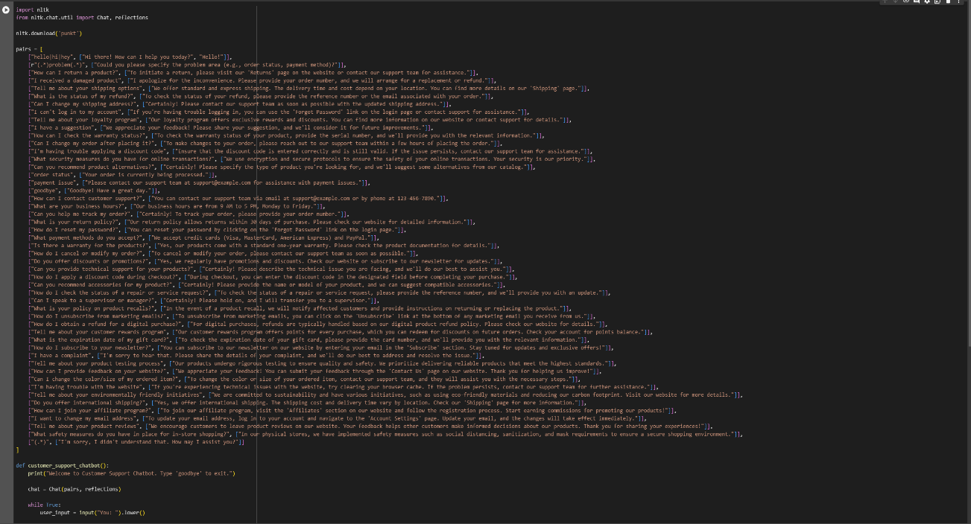

OUT PUT:

Fig.5:

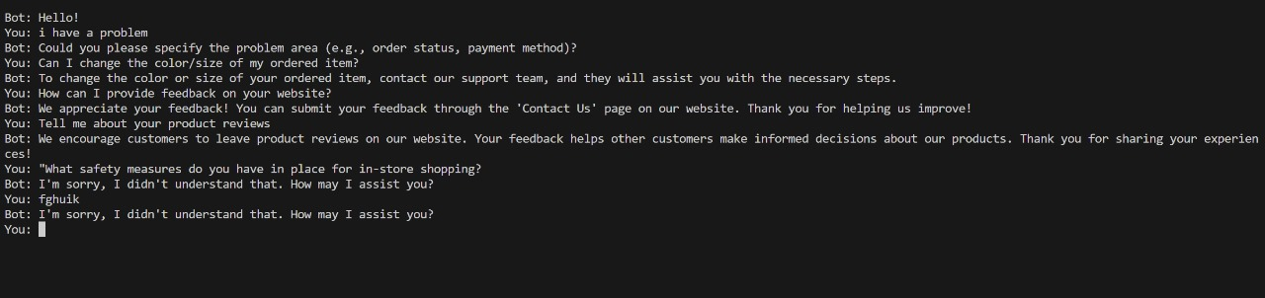

Fig.6:

